LAB DOCUMENTATION: MINIMAX ALGORITHM AND ALPHA-BETA PRUNING
Lab Title: Implementation and comparison of Minimax and Alpha-Beta Pruning on a binary game tree.

1. Problem Statement
The primary objective of this laboratory exercise is to analyze and evaluate a binary game tree through the Minimax decision strategy, where the MAX player maximizes the outcome and the MIN player minimizes it. Additionally, Alpha-Beta Pruning is integrated to optimize search efficiency by pruning irrelevant subtrees without altering the final optimal value.

2. Minimax Algorithm
Minimax evaluates game states recursively starting from the leaf level up to the root node. Each MAX decision node selects the maximum value among its children, whereas each MIN decision node selects the minimum value.

2.1 Hand-Traced Minimax Tree
Figure 1. Hand-traced Minimax and Alpha-Beta decision trees with execution comparison table. 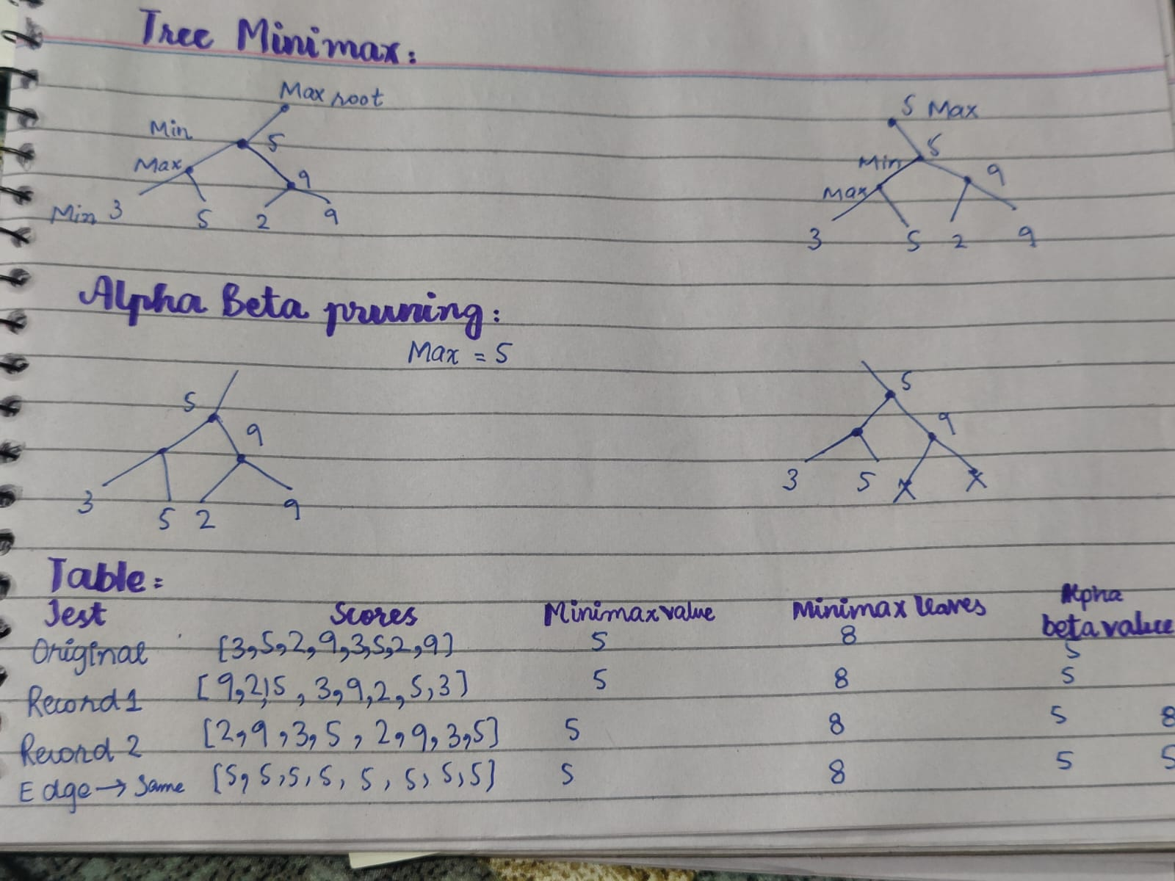

2 2. VS Code implementation of Minimax algorithm with leaf counter.
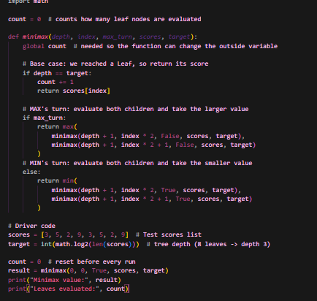

2.3 Minimax Output
Figure 3. Terminal execution output for Minimax algorithm.

3. Alpha-Beta Pruning
Alpha-Beta Pruning optimizes Minimax by maintaining two bounding values: Alpha (MAX's guaranteed minimum score) and Beta (MIN's guaranteed maximum score). Branches that cannot influence the final root outcome are pruned via early loop terminatio

3.1 Hand-Traced Alpha-Beta Tree
Refer to Figure 1 for the hand-drawn tree demonstrating pruned branches marked with cutoffs.

3.2 Alpha-Beta Code Screenshot
Figure 4. VS Code implementation of Alpha-Beta Pruning algorithm.

3.3 Alpha-Beta Output
Figure 5. Terminal execution output for Alpha-Beta Pruning algorithm. 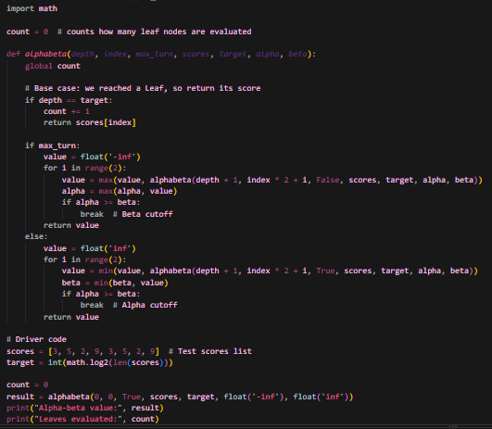

4. Comparison Table
Test Case | Leaf Values | Minimax Value | Minimax Leaves | Alpha-Beta Value | Alpha-Beta Leaves
Original | [3, 5, 2, 9, 3, 5, 2, 9] | 5 | 8 | 5 | 6
Reorder 1 | [9, 2, 5, 3, 9, 2, 5, 3] | 5 | 8 | 5 | 8
Reorder 2 | [2, 9, 3, 5, 2, 9, 3, 5] | 5 | 8 | 5 | 8
Edge Case | [5, 5, 5, 5, 5, 5, 5, 5] | 5 | 8 | 5 | 5

5. Edge Case Test
When all leaf nodes evaluate to identical scores ([5, 5, 5, 5, 5, 5, 5, 5]), both algorithms return 5, with Alpha-Beta performing fewer evaluations due to early cutoff conditions.

6. Interpretation & Analysis
Both algorithms produce the identical optimal root value (5). Minimax evaluates all 8 leaf nodes regardless of structure. Alpha-Beta Pruning reduces leaf evaluations based on branch ordering; optimal ordering maximizes pruning efficiency without impacting the final decision score.

